PRACTICE LEAFLET
Welcome to Palatine Group Practice

We are a long established practice, in a modern purpose built surgery conveniently located within the grounds of Noble’s Hospital. We hope you find this document helpful.

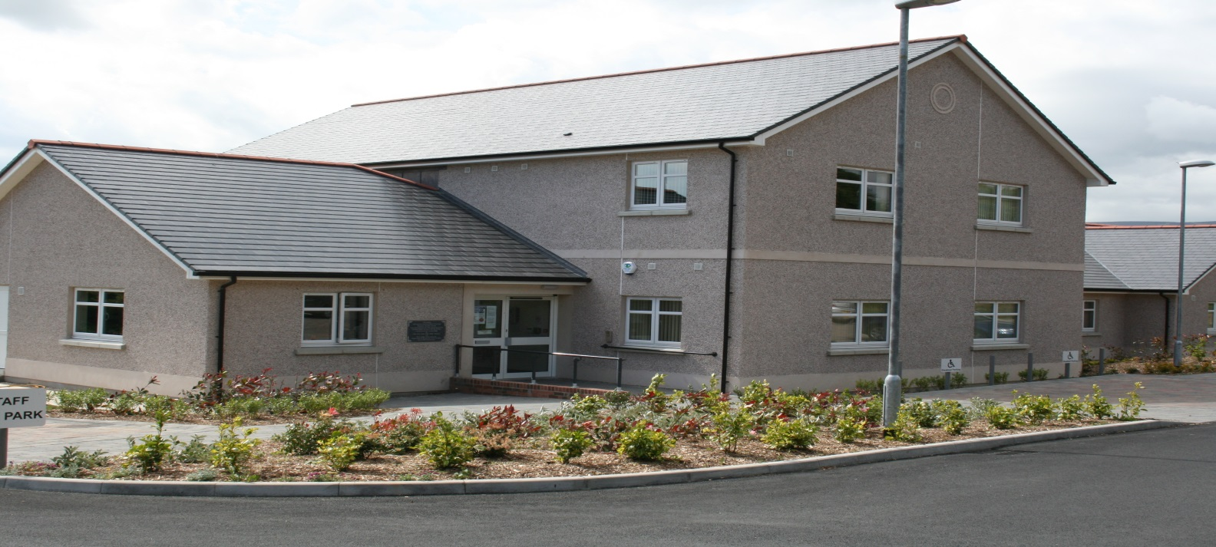

Our partnership consists of 8 general practitioners with a compliment of following health care professionals;

- Physician Associate, Advanced Nurse Practitioner, Practice Nurses, Healthcare Assistant/Phlebotomist, Pharmacist
- Attached Health Team – Health Visitors, District Nursing, School Nursing & Community Midwives

Opening times (Monday to Friday)

We are open Monday to Friday (closed weekends and Bank Holidays). The practice doors are open and reception is operational from 08:00 to 18:00, the telephone lines of 623931 are open from 08:00 to 18:00. A recorded message from 18:00 to 08:30 will give details of what to do if you require urgent assistance outside of practice hours.

Doctors

- Dr Julie Cretney MB ChB, BMed Sci (Hons), DRCOG (Reg Sheffield 1989)
- Dr Alan Peden MB ChB (Reg Aberdeen 1990)
- Dr Adrienne Rogers MB BCh, BAO, MICGP, MRCPCH DRCOG (Reg Galway 2007)
- Dr David Foster MB ChB DRCOG MRCGP (Reg Birmingham 1984)
- Dr Salma Rafique MBBS MRCGP (Reg Peshawar 2007)
- Dr Emily Gresham MB ChB (Reg Liverpool 2014)
- Dr Dale Kalloo MBBS (Reg 2002)
- Dr Nathan Golban MD BSc MRCGP (Reg 2012)

Consulting Times – strictly by appointment only.
Day | am/pm | Cretney | Peden | Rogers | Foster | Rafique | Gresham | Kalloo | Golban
Mon | am | 08:30 | 08:30 |  | 09:00 | 09:00 | 09:00 |  | 09:00
 | pm | 14:00 |  |  | 14:00 | 14:30 |  |  | 14:00
Tue | am |  | 08:30 |  | 09:00 |  | 09:00 | 09:00 | 09:00
 | pm |  | 14:00 |  | 14:00 |  | 14:30 | 14:00 | 14:00
Wed | am | 08:30 | 08:30 | 08:30 | 09:00 | 09:00 |  |  | 09:00
 | pm | 14:00 |  | 14:30 | 14:00 | 14:30 |  |  | 14:00
Thu | am | 08:30 | 14:00 |  |  | 09:00 | 09:00 | 09:00
 | pm | 14:00 |  |  |  | 14:30 | 14:30 | 14:00
Fri | am |  | 08:30 | 08:30 | 09:00 |  | 09:00 | 09:00
 | pm |  | 14:00 | 14:30 | 14:00 |  | 14:30 | 14:00

Our appointments are usually 10-20 minutes long and are intended for a named patient with one or two problems. Please notify the receptionist if you require longer and we will try to arrange this.

We offer a mix of face to face appointments and telephone appointments and our administrative team have been trained in ‘signposting’, meaning they will ask for a brief reason for the appointment to try to ensure an appropriate appointment is allocated.

Appointments can usually be pre-booked within 4 weeks. If you require a more urgent appointment please contact the practice at 08:30 any morning so we can offer a consultation on the day.

If we have your permission you will be sent text reminders with your appointment details. Please let us know if you are unable to attend your appointment, so that we can give it to someone else in need.

Physician Associate

- Georgia Horsley

Practice Nursing Team

- Heather Gill Advanced Nurse Practitioner
- Kelly Jennings Nurse Prescriber
- Lois Clague Practice Nurse
- Angela O’Donnell Healthcare Assistant/Phlebotomist

Pharmacist

- Hina Iqbal

Doctors in Training and Medical Students

We are an accredited GP Training Practice and we host many doctors at various points in their training;

- GP speciality trainees (qualified doctors training to be GPs). They are closely supervised and have longer appointments. Our accredited trainers are Dr Adrienne Rogers and Dr Emily Gresham.

- Foundation year 2 Doctors (doctors in their second year following qualification as a doctor who are learning within a GP setting but who have not yet chosen their speciality). Lead F2 Trainer is Dr Alan Peden.

Medical Students

We often welcome medical students from Manchester University for 4 week placements. You will be informed if there will be a student observing the clinician and you have the option of asking the student not to be present.

All doctors in Training and medical students have a nominated partner mentor who will be supervising and overseeing their work

Admin Team

- Hayley Varney Practice Manager
- Alison Kerruish Assistant Practice Manager

We have a large admin team who are here to help you.

Practice Catchment Area

Our practice area covers from Port Grenaugh in the south, via St Marks and to St Johns in the west to Injebreck and Baldrine in the north. Only those with a current address within our boundary may register at Palatine Group Practice. Any patient who relocates outside our boundary will be unable to remain on our list and will have to seek GP services within their new area. You can contact a GP practice in your new area directly to register or alternatively Manx Care at Crookall House will be happy to advise you on 642608.

Registering at the Practice
Please see details of our catchment area above. If you wish to register with us, please attend the practice reception with photographic identification and proof of address. You will be issued with the relevant forms which on completion should be handed back to the receptionist to verify the details. Occasionally we may be closed to new registrations and will update our website accordingly.

Temporary Registration/Visitors to the Island

Any person registered with a UK GP will be able to receive free NHS treatment for a limited period of time (up to a maximum of 6 months).
Anyone without a registered UK GP can request private urgent treatment. You will be charged for this service:

£50 for an urgent appointment £100 for a home visit

Payment will be required in advance by cash or card via the practice reception.

Further information regarding the Isle of Man’s Reciprocal Healthcare Agreement is available online at www.gov.im/rha, by e-mail to dhsc@gov.im or telephone 685816.

Disabled Access

The surgery is fully accessible to people with limited mobility. All patient areas are on the ground floor. Staff are always happy to assist and we have an intercom at the front access door should you require any help. We keep a wheelchair in the front foyer and we have a number of designated parking bays.

Home Visits

If you are truly housebound then we can arrange for a home visit when you are ill. Please let us know by 10:00 so that we can make planning arrangements for the day.

Repeat Prescriptions

There are several ways to order repeat medication:

- Via Patient Access – if you are not signed up please bring photo ID to your next visit and the admin team will give you the necessary secure sign up details and instructions.
- Via our website www.palatinegrouppractice.im and follow the link.
- By e-mail to palatineprescriptions@gov.im.
- Drop your repeat prescription slip or request letter indicating which medications you require into the red box adjacent to the practice reception.
- Complete the tear off slip from your previous prescriptions and drop it into or post it to the surgery ensuring you enclose a stamped addressed envelope should you wish us to return it to you. A written request will also be acceptable.

You can collect your prescription from the surgery or let us know your preferred chemist and we will send it to them on your behalf.

Repeat prescriptions must be requested in writing via the above methods and require 48 hours’ notice (excluding weekends and bank holidays). If you are collecting from a pharmacy please allow 72 hours (excluding weekends and bank holidays). Telephone requests for repeat medications cannot be accepted.

Test Results

Most test results are reported within 1-2 weeks. An appropriate clinician will check your result and leave a note that the receptionist can relay to you. All results are confidential so will only be given to a patient themselves or a guardian in the case of a minor. A GDPR consent form can be completed should you wish to nominate someone to be able to speak on your behalf (collect from reception).

Sick Notes

A doctor’s sick note is not legally required for absences of less than 13 days. A self-certificate (SC1) should be completed and returned to your employer. SC1 forms are available from the post office or surgery.

Changing Contact Details?

Please remember to inform us in writing immediately if you change any of your contact details.

Private Work – Medicals

The practice is usually able to carry out private medicals, these are usually in connection with insurance or HGV/PSV driving etc. There is a payable up front free for any medical and will be in line with BMA recommended rates. Please note the practice is not obliged to carry out any private work.

NB please note we do not countersign passport application forms.

Travel Vaccinations

Travel associated vaccinations are not available on the NHS. You should contact the practice if you wish to enquire about travel vaccinations and the admin team will advise you of the process. Please note there are various charges including the prescription fee and for the administration of the vaccine and ensure that the practice is given as much notice as possible prior to travel.

Chaperones

For intimate examinations you have the right to request a chaperone at your appointment. Your clinician may also request chaperone services from a member of the nursing or admin team.

For Accident and Emergency and Casualties

We do not have the facilities to deal with casualties so you should attend the A&E department at Noble’s Hospital. Services are provided on an appointment only basis.

Access to Patient information/Data Confidentiality

Data is handled with complete discretion and in accordance with Data Protection and GDPR laws. Information is only passed to authorised 3rd parties and with the patient’s consent in writing (eg requested insurance reports or Subject Access Requests).

Complaints, suggestions & feedback

All members of the team aim to offer a professional, friendly service at all times but we may not always get it right.

If you have any complaints please address them to the Practice Management Team in the first instance.

In the majority of cases we are able to help and find a resolution.

However if you feel we have not dealt with your complaint satisfactorily you can contact the Primary Care Team at Manx Care on 642608.

If you have any improvement suggestions you can send them to us via post or e-mail. Likewise we love to hear feedback on anything we have done well. It can be a wonderful morale boost for those involved.

Discrimination Policy

The practice does not discriminate on the following grounds; race, gender, age, social class, sexual orientation, appearance, disability or medical condition.

Violent and Abusive behaviour - Zero Tolerance Policy

Our staff come to work to care for others and we expect them to be treated with courtesy and respect at all times.

In line with the rest of the NHS, we have a Zero Tolerance Policy and aggressive, intimidating, threatening or violent behaviour towards in our staff will not be tolerated and in most cases will result in a warning letter. In extreme cases you will be removed from our practice list with immediate effect.

We will not hesitate to call the police for assistance when necessary.

Primary Care Services – Manx Care

Details regarding the provision of medical services for the Isle of Man can be obtained from Crookall House, Demesne Road, Douglas. Telephone 642608.

Directions

From the Jubilee Oak roundabout on the TT course, follow the signs towards the hospital. At the roundabout just before the hospital site entrance, carry on into the hospital campus and take the first left, down past the helicopter pad, towards A&E. Follow the road past A&E and the practice is further down on the left. It is well signposted. There are diversions during TT and Manx Grand Prix race periods.

Palatine Health Centre

Find us on Facebook:
Palatine Group Practice IOM

Reviewed 10 April 2024.

